

Welcome to the Defence Surveyors’ Association

**President: Major General Roy Wood (Retired)**

**Chairman: Dr John Knight**

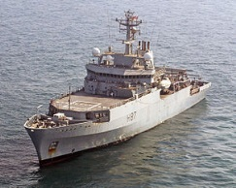

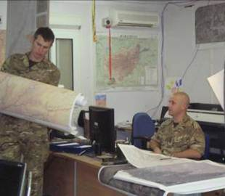

**Introduction by the Chairman**

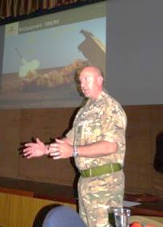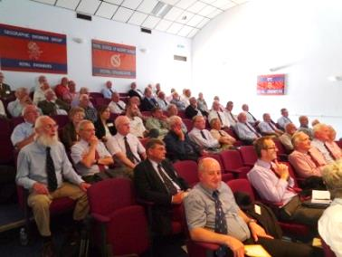Welcome to the family of defence surveyors! Now that you are a professional geo intelligence practitioner you will want to continue with your professional development. The DSA is one avenue that gives this opportunity. I would like to explain what the DSA does and encourage you to join in order to keep in contact and up to date with affairs in our exciting business. I am particular keen to attract those currently serving in defence appointments.

**What is the DSA**

DSA comprises members from the defence, industry, academe and private sectors who have a collective interest in defence surveying, mapping, charting and geospatial intelligence. The common thread is the application of science and art to geographic interpretation for defence purposes.

**DSA Aim**

The aim of the DSA is to promote an understanding and appreciation of defence surveying, mapping, charting and geospatial intelligence in historical, current and future contexts and to keep past and current members of that community in touch with one another.

**DSA Objectives**

The objectives of the DSA are to:

* Promote the sharing of knowledge of current and past achievements, future development and potential opportunities in the areas of defence surveying, mapping, charting and geospatial intelligence.
* Recognise and reward excellence and achievement within the DSA area of interest within the armed forces and related institutions with the awarding of prizes.
* Support events to encourage socialising and networking amongst those interested in the defence geographic matters.
* 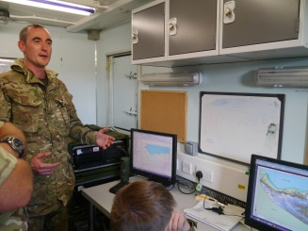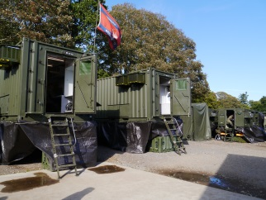Support activities to preserve the defence surveying, mapping, charting and geospatial heritage.

**Our Activities**

In line with our objectives we organise technical seminars, currently two per year, dinners with guest speakers, and publish the *Ranger* which is our annual technical publication to which we encourage all members to contribute. We also award prizes to defence personnel who have made outstanding contributions to their organisations and we organise visits to places of defence interest.

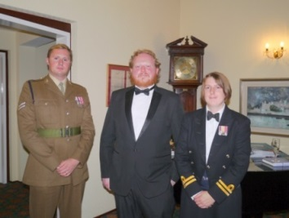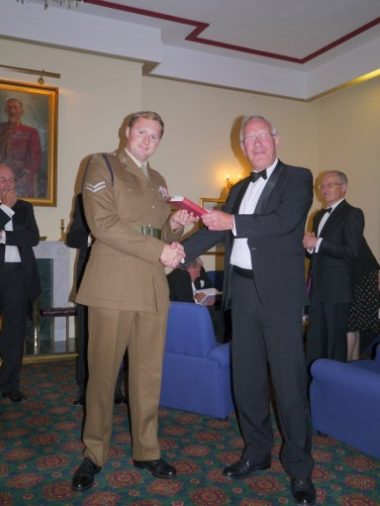

**Who can join?**

Those who are involved in, or have an interest in, defence surveying, mapping, charting and geospatial intelligence.

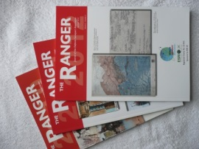

**Membership Benefits**

Benefits of membership include:

* Information and education on what is happening in the Defence Geospatial Intelligence domain.
* Access to seminars on historical, current and the future topics related to the interests of the DSA.
* Access to DSA’s publications and other publications on defence surveying, mapping, charting and geospatial intelligence.
* Documentation on the heritage of defence surveying, mapping, charting and geospatial intelligence.
* Interaction with members at DSA professional and social events.

**Early History**

In 1927, a group of officers who had contributed to the great success of the Artillery in 1917-1918 by the provision of counter-bombardment data from Sound Ranging & Flash Spotting and led by the Nobel Prize winner Sir Lawrence Bragg and Harold Hemming formed the Field Survey Association as an old comrades’ association and a known pool of expertise if called upon for another war.

The association was in abeyance during the Second World War but many members again did active service.  The association resumed activities in 1945 and, in 1997, was renamed the Defence Surveyors’ Association more properly to reflect the multi-disciplined changing nature of Geographic Intelligence support to the three Services.

**Joining**

So how do you join and how much does it cost?

All you need to do is to complete an application form (see Join tab on our web site) and e-mail it to the Honorary Membership Secretary [applications@defencesurveyors.org.uk](mailto:applications@defencesurveyors.org.uk)

The annual membership fee is £15 starting on 1 Jan. We also seek to claim Gift Aid.

**How to contact us**

DSA

c/o Royal School of Military Survey

Denison Barracks

Hermitage

Thatcham

Berkshire

RG18 9TP

You can also visit our web site at:

[www.defencesurveyors.org.uk](http://www.defencesurveyors.org.uk)

****[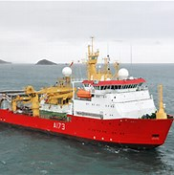](http://www.bing.com/images/search?q=hms+protector&FORM=IARRTH&ufn=HMS+Protector&stid=bf371a4e-dc10-4309-b8e8-cada782bb382&cbn=EntityAnswer&cbi=0&FORM=IARRTH)

